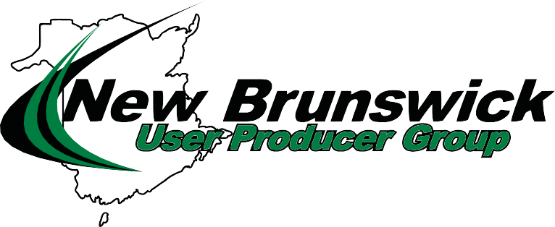
18th Annual Seminar, May 8th 2019 Hugh John Flemming Forestry Center
1350 Regent St., Fredericton, N.B. E3C 2G6
Agenda
8:00 - 8:30 Coffee / Registration
8:30 - 8:45 Welcome, Introduction of NBUPG Board, Presentation of Scholarships / IWK
8:45 - 9:30 “Integrated Polymer Modified Asphalt Cement into Production: Contractor’s Perspective
Trevor Moore, Miller Group.

9:30 - 10:15 “Benefits of Polymer Modification” Bob Klutz, Kraton Polymers.

10:15 - 10:30 Nutrition Break

10:30 - 11:10 “Innovative Pavement Maintenance and Preservation” Alain Cormier, McAsphalt Industries.

11:10 - 12:15 “Compaction Best Practices” Dr. Amma Wakefield, Asphalt Institute.
12:15 - 1:30 LUNCH BREAK, SPONSOR IRVING OIL: Cody Fullerton 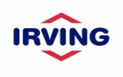

1:30 - 2:30 “Intelligent Compaction for QA/QC” Dr. Amma Wakefield, Asphalt Industries.

2:30 - 3:15 “How to prevent Raveling in H.M.A. Pavements” Dr. Xiomara Sanchez, U N B.
3:15 - 3:35 Nutrition Break
3:35 - 4:15 “Benefits of optimizing tack coat spray rates” Dr. Sina Varamini, McAsphalt Industries Ltd.
4-15 - 4:30 Questions / Door prizes, Adjournment
4:30 - 5:30 “Social Hour, Barbeque” SELCO Equipment Daryl Lisson.

April 23, 2019

